# ESO Admin Level Setup

## Re-Seed

The default initial primary key value for clients and users is not sufficiently large enough to avoid conclusions with history data, therefore higher initial values (10,000,001) will be seeded.

In the Data Extraction and loading package, navigate to the Base Configuration folder, then navigate to the ReSeed folder. In SQL Server management studio open a query window and select the database appropriate for the Base Configuration. Open the file “ReSeed Before Base Configuration.sql” and execute it.

**Note: the reseed script only sets values into a temporary cache. In order to preempt the purging of the cache, the configuration steps for Client Setup listed below should be done immediately after the execution of the reseed script. If for some reason this cannot be done, the reseed script can be executed again prior to the configuration steps. The steps proceeding Client Setup can be defer until later.**

## Client Setup

Login to the ESO Instance the “Waveadmin” credentials:

In the top search dialog enter Client Setup, click on the Client Setup link to access the Client Setup.

From the Client browse page, Click Add Client. The following dialog will be displayed.

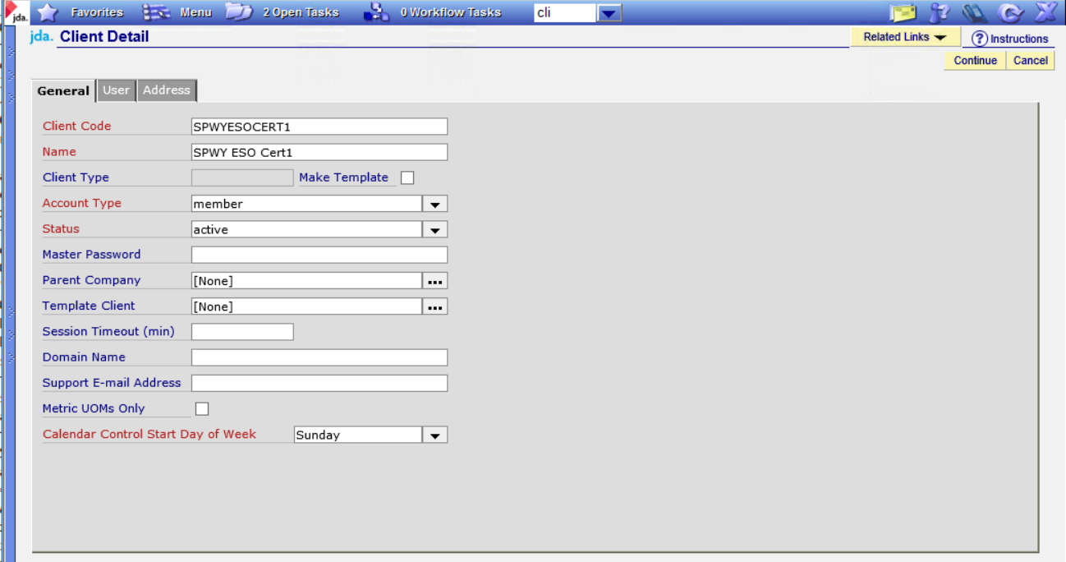

Add values for the Client Code and Client Name.

All the remaining values should be left as default (They can be changed later).

Click the User tab.

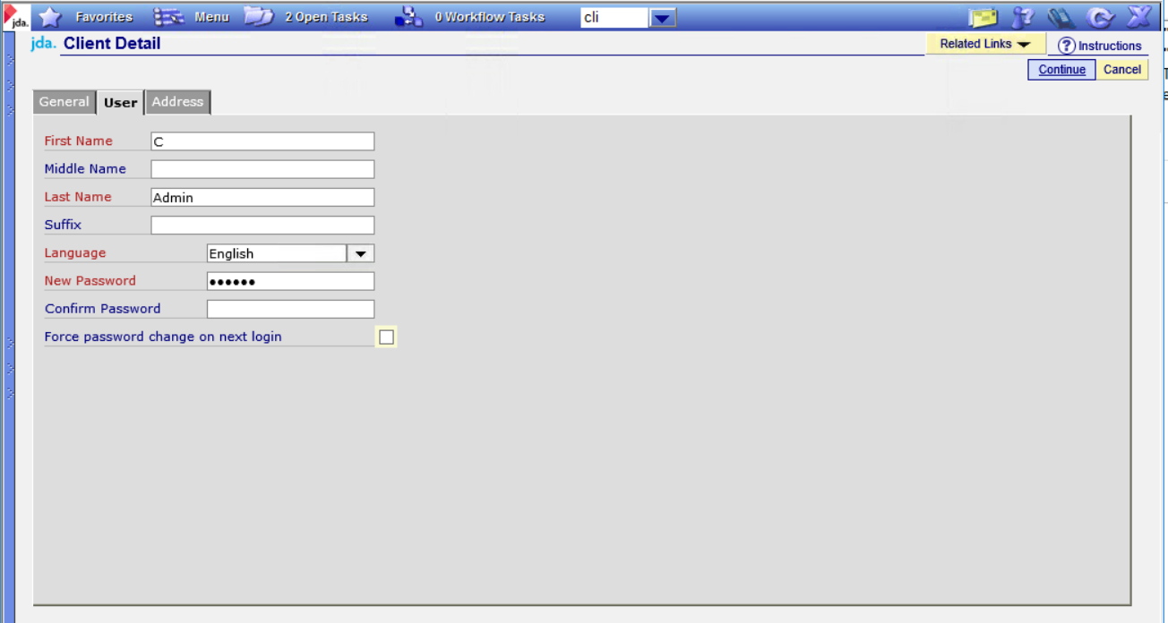

Enter information in the following fields:

* First Name
* Last Name
* Language
* Password fields

This will create a Client Admin user based upon the First and Last Name. In the above example, the user will be created with the login of CAdmin.

Click the Address tab.

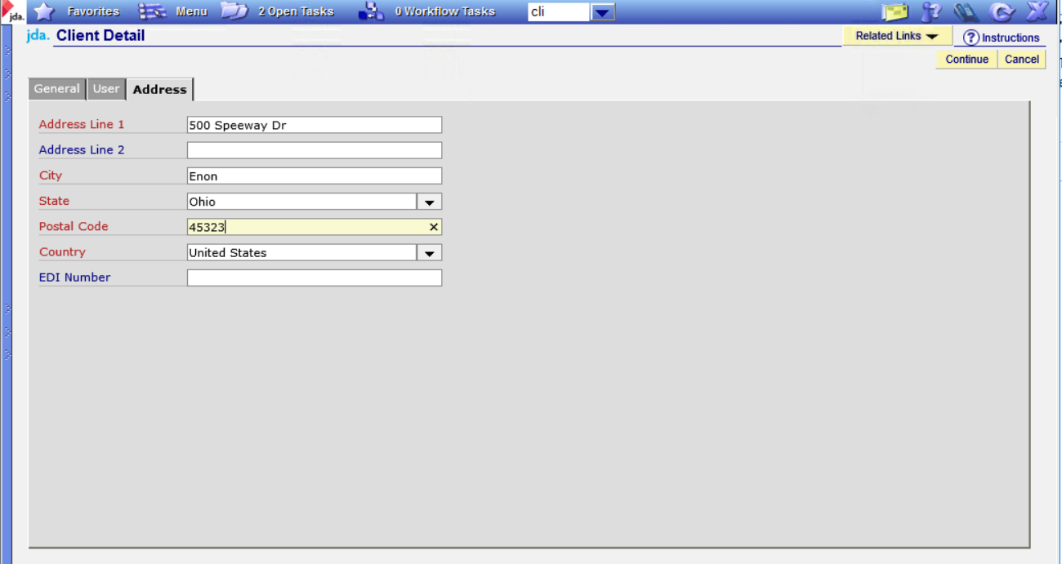

Click Continue. A confirmation message is displayed.

Enter information in the following fields:

* Address Line 1
* City
* State
* Postal Code
* Country

Click Continue.

Note the user name assigned on the message box and click OK.

Click the Language tab and choose a default language.

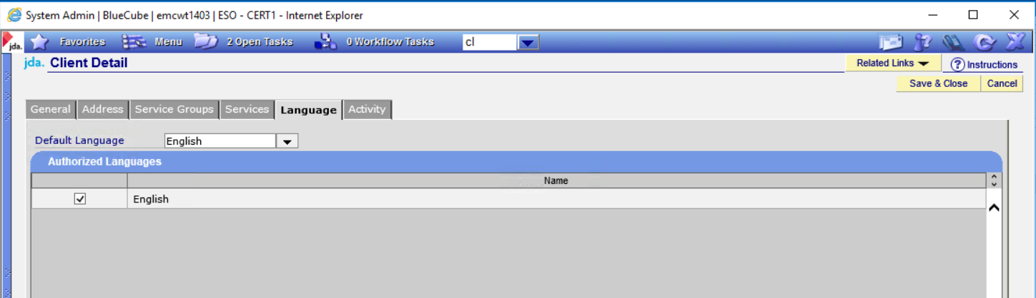

*** Need to add screen shot to capture the internal client id value.

Click Save & Close.

## External System Setup

In the top search dialog enter External System Setup, click on the External System Setup link to access the External System Setup.

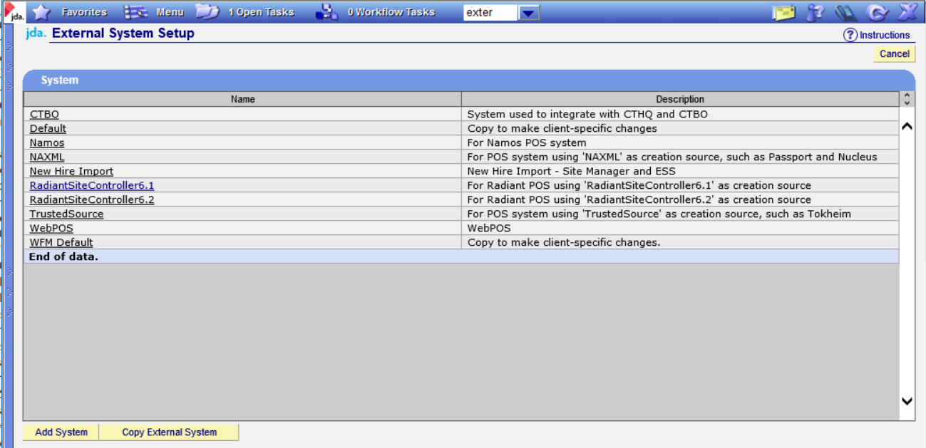

Click Copy External System

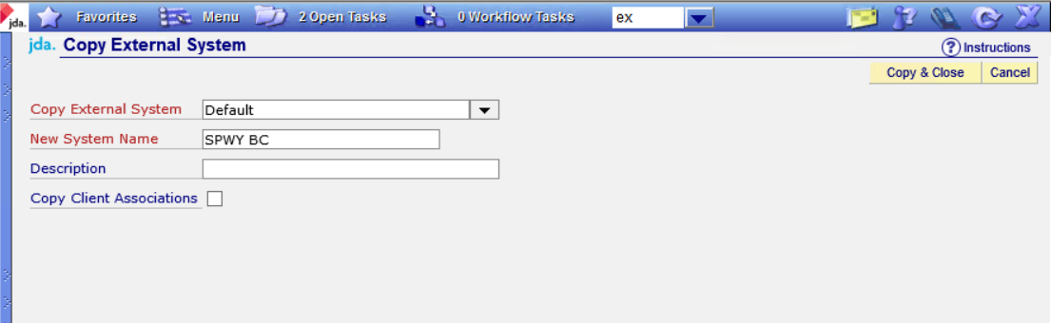

Select “Default” as the Copy External System.

Enter a New System Name of SPWY BC, to indicate that the this import source is from the legacy BlueCube system.

Click Copy & Close.

The new system should be displayed in the browse grid.

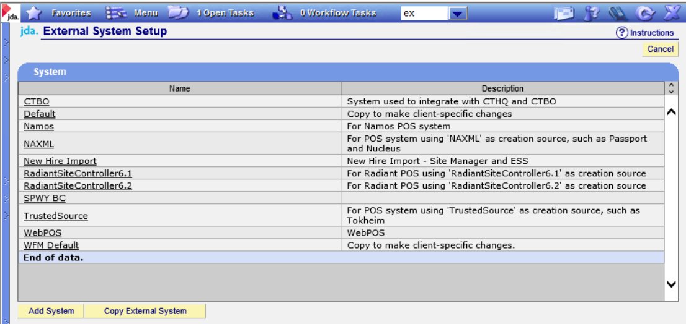

Click on the link for SPWY BC. Ensure that the Org Unit/ BU Group Entity has the key set to “Org Code”.

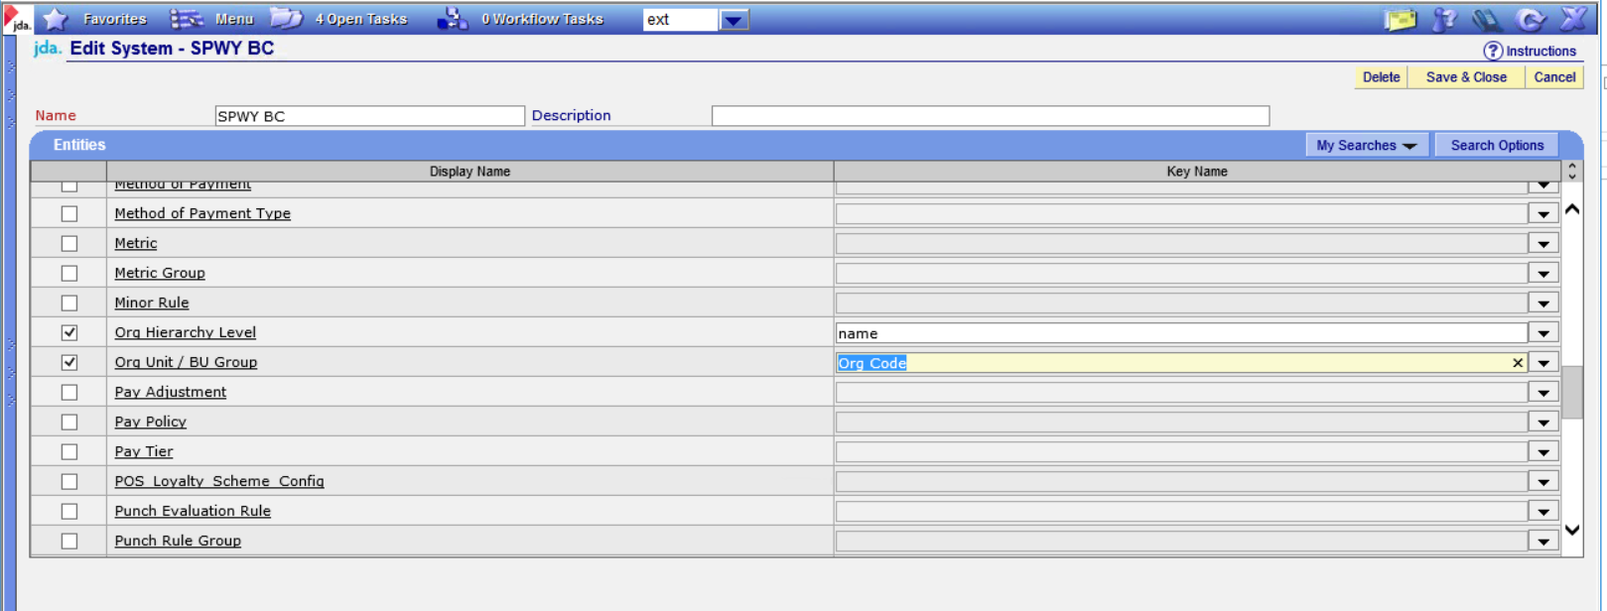

If the key is not set to “Org Code”, change the value to “Org Code” and click Save and Close.

## Cross Reference Client Setup

In the top search dialog enter Cross Reference, click on the Cross Reference Client Setup link to access the Cross Reference Client Setup.

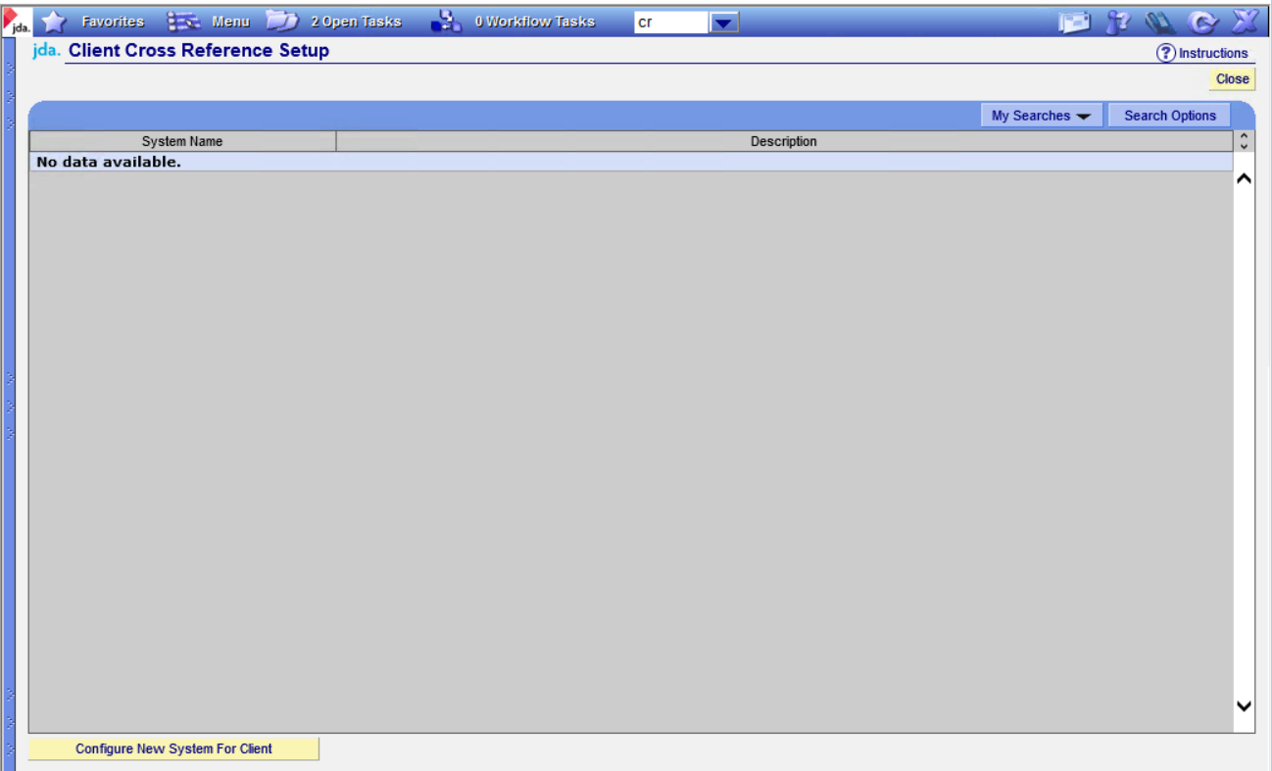

Click Configure New System for Client

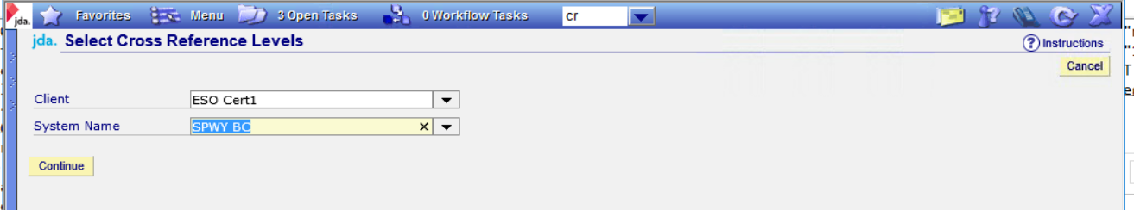

Select the Client Name and the External System Name created previously.

Click Continue.

The Client Name and the External System should be displayed in the browse page.

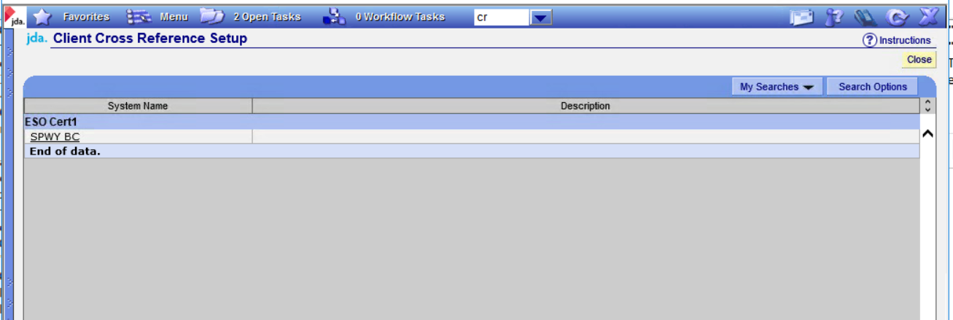

Click on the Name of the System to display the Cross Reference Levels.

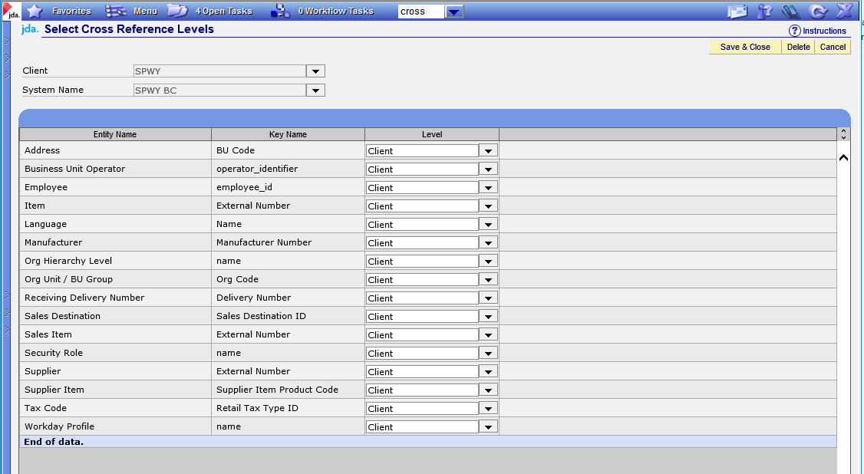

Ensure that all “Levels” are set to “Client”.

Ensure that each Entity Name is listed based upon the example above.

Admin level setup is complete, the browser session should be closed.

# Client Admin Level Setup

## Default Services

This step requires write access to the ESO database.

In the Data Extraction and loading package, navigate to the Base Configuration folder, then navigate to the Default Services folder. In SQL Server management studio open a query window and select the database appropriate for the Base Configuration. Open the file “Add Default Services.sql” and execute it.

## Workday Profile Setup

In the top search dialog enter Workday Profile, click on the Workday Profile Setup link to access the Workday Profile Setup

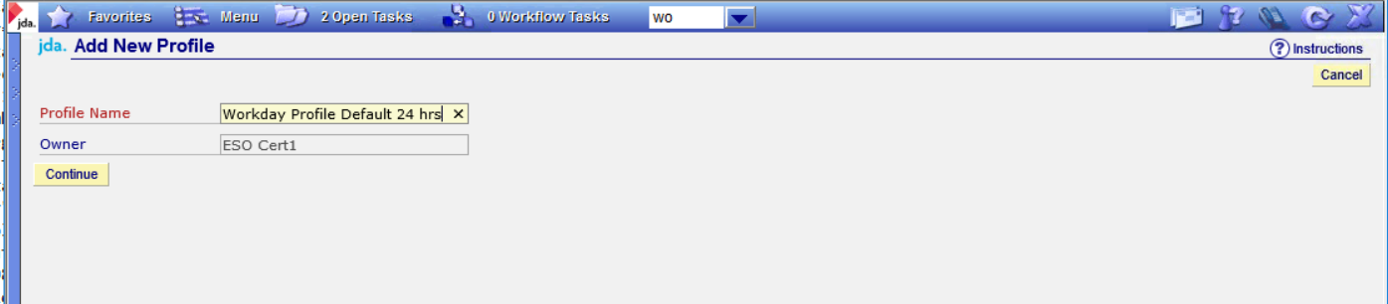

Add a new profile named “Workday Profile Default 24 hrs”.

Click Continue.

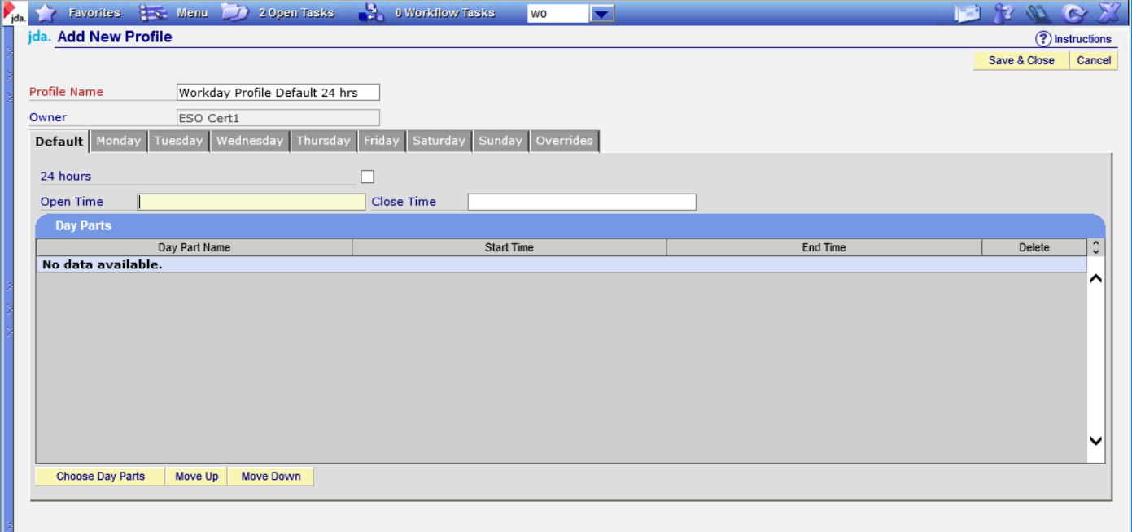

It is not necessary to complete the remainder of the configuration.

Click save and close.

## Organization Hierarchy Level Setup

In the top search dialog enter Hierarchy Level Setup. Click on the link.

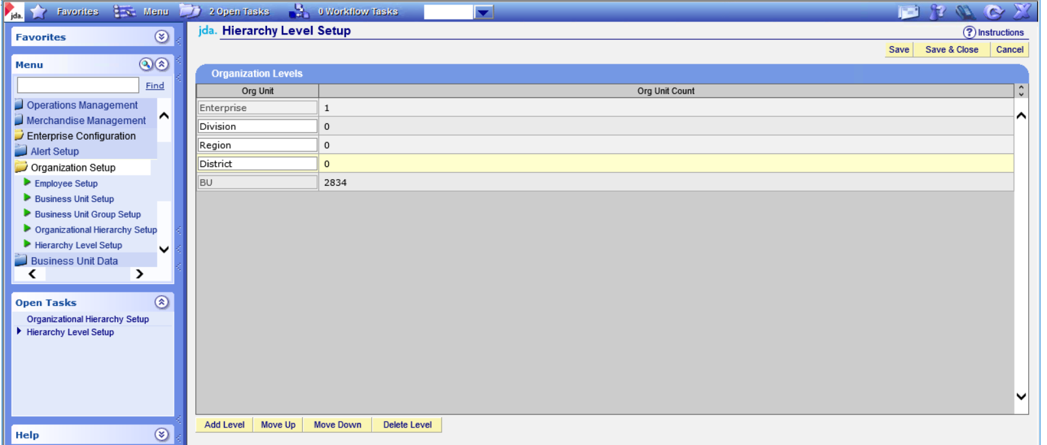

Click Add Level and add “Division” under “Enterprise”.

Click Add Level and add “Region” under “Division”.

Click Add Level and add “District” under “Region”.

Click Save and Close. A warning message will be displayed.

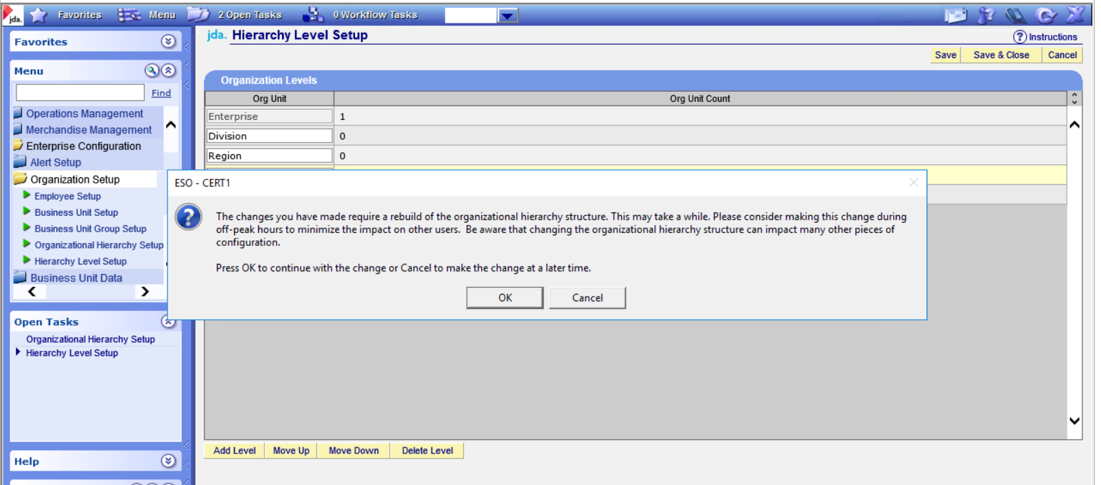

Click Ok on the warning dialog.

## Item Category Level Setup

In the top search dialog enter Item Category Level Setup. Click on the link.

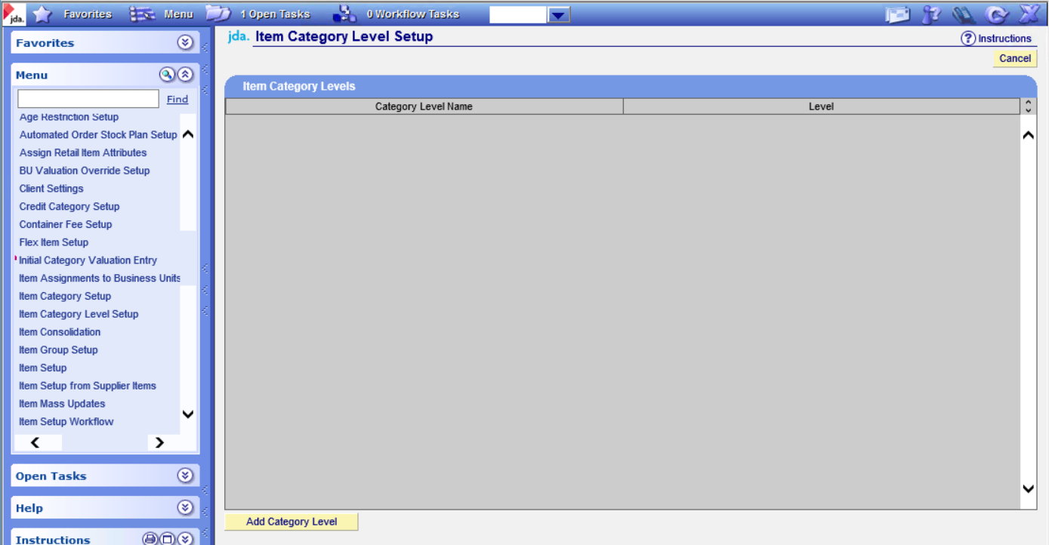

Click Add Category Level to display the New Item Category Level page.

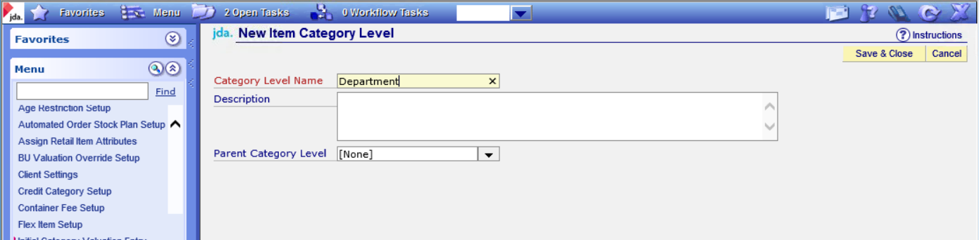

Enter the “Department” level without a parent category level.

Click Save and Close.

Add another category level for “Category” using the “Department” as the Parent Category Level.

Add another category level for “Subcategory” using the “Category” as the Parent Category Level.

When completed, the browse screen should look as shown below.

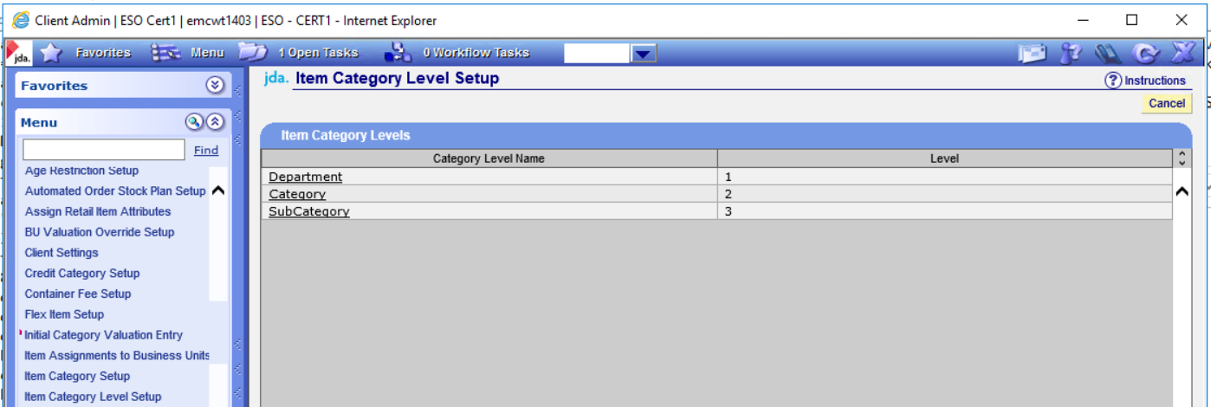

## Client Settings

In the top search dialog enter Item Client Settings. Click on the link.

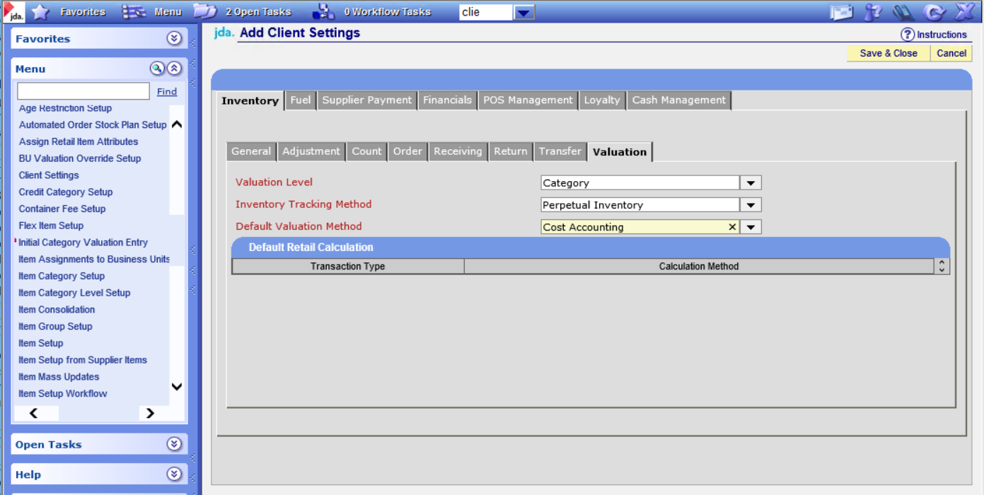

Navigate to the inventory tab.

Set the Valuation Leve to “Category”.

Set the Inventory Tracking Method to “Perpetual Inventory”.

Set the Default Valuation Method to “Cost Accounting”.

Click Save and Close. A warning message will be displayed. Click Ok.

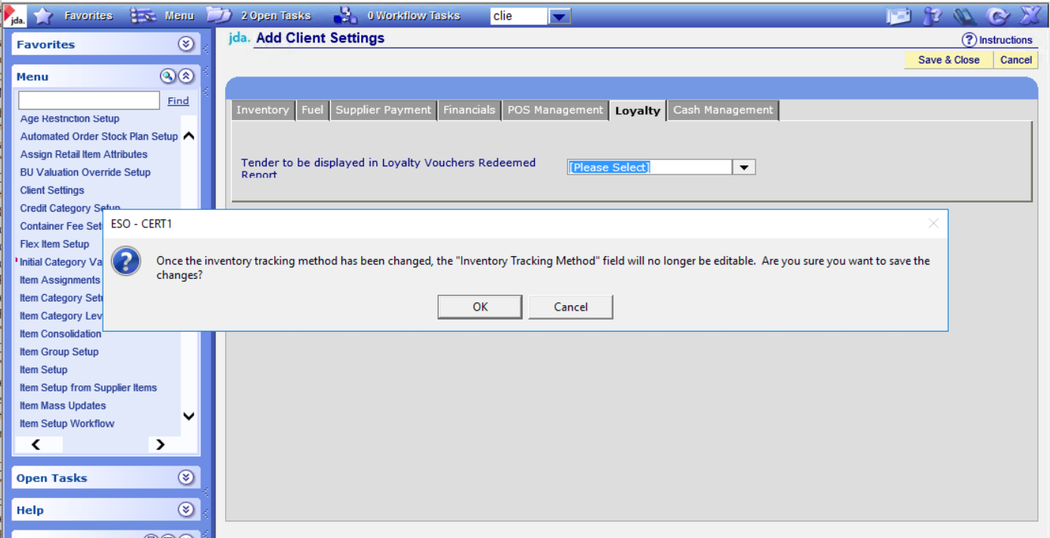

Save and close the Client Settings

## Import Setup and Testing

In the top search dialog enter Import Setup.

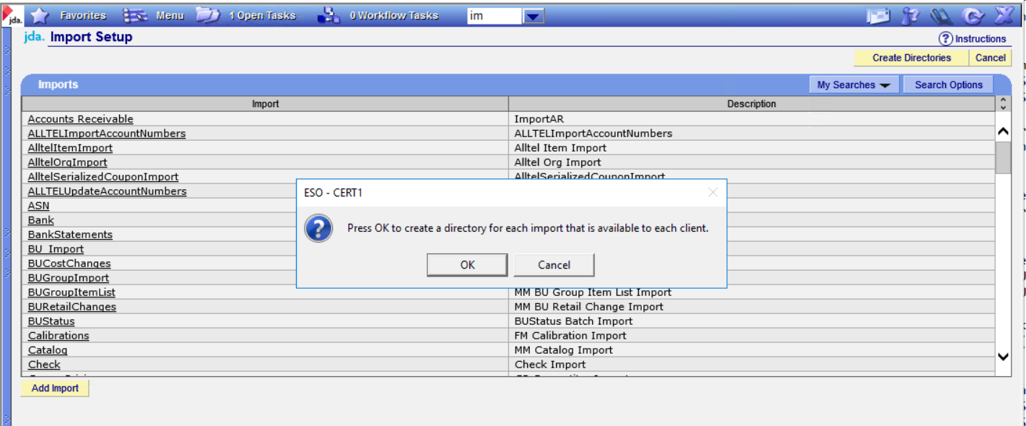

Click Create Directories.

Click OK and the dialog.

Click cancel when the operator is complete in order to close the page.

In the top search dialog enter Import Configuration Test.

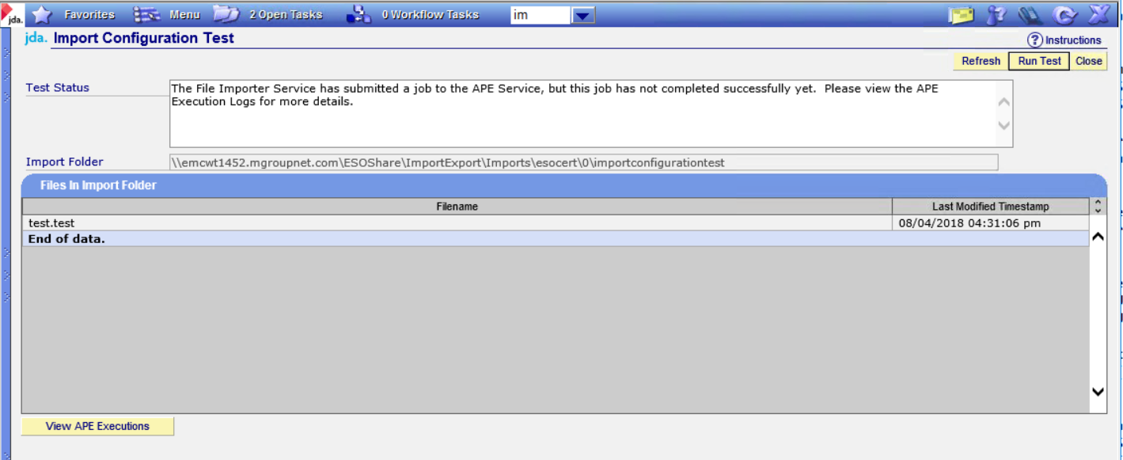

Click Run Test.

A message will be displayed if the test job was submitted successfully.

Click Close to exit the page.

In the top search dialog, entered “Queued Job Viewer”. Click on the link to display the APE Execution Jogs Queue.

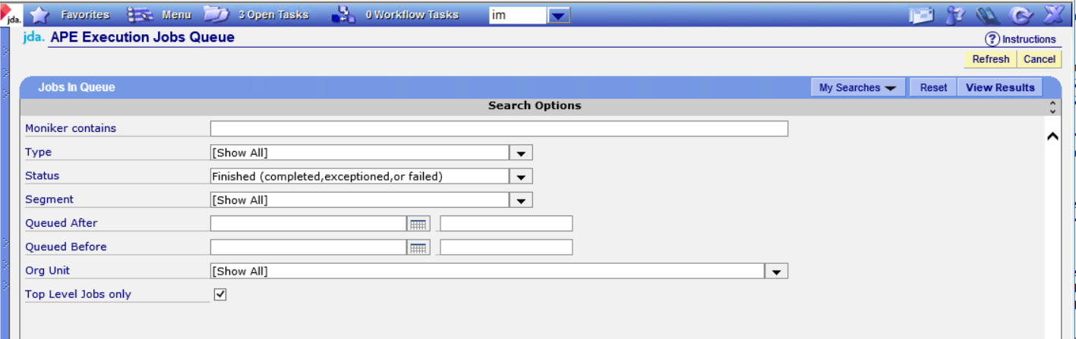

Set the search criteria as above and Click View Results.

Near the top there should be a job titled APE.Jobs.ImportRouter.

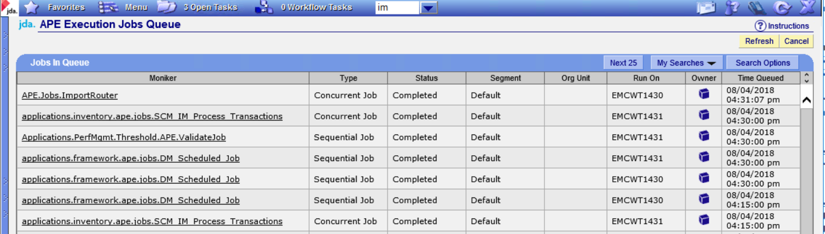

Click on the moniker link and navigate to the Task tab to display the job tasks.

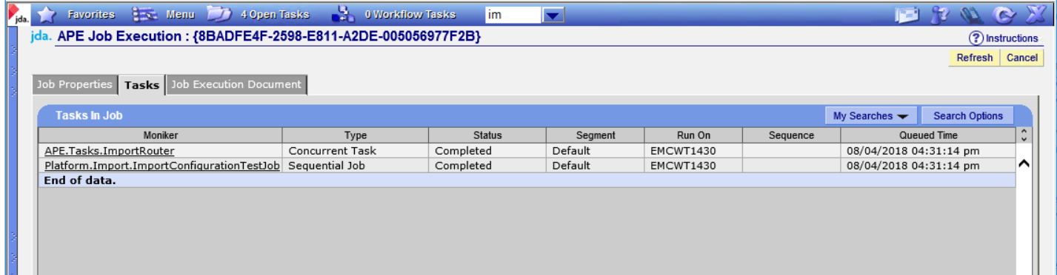

Verify that the task completed without error.

Click Cancel to close the page.

Click Cancel again to close the Queued Job Viewer.

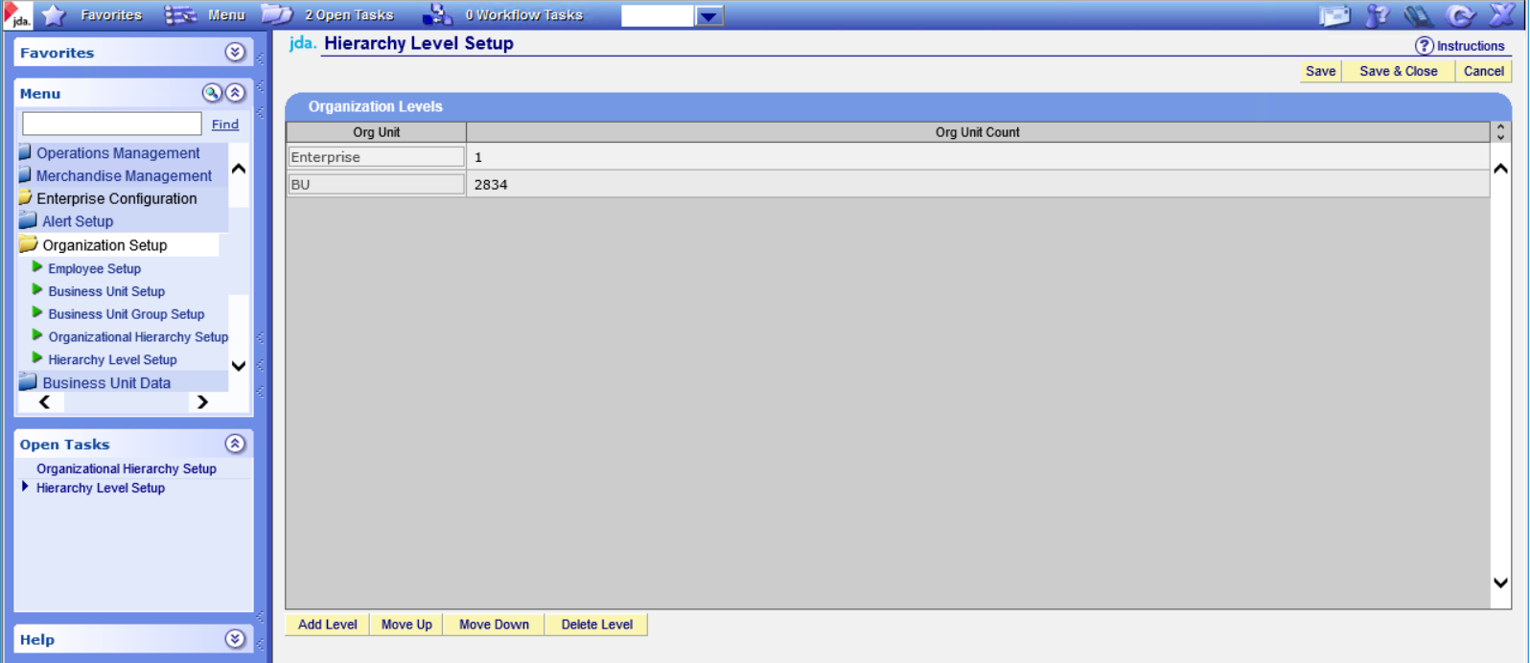

# Additional Database Scripts

## Bump up pre-defined Date tables

In the TimeZone_2016 database upgrade package provided by JDA, navigate to the Generic.AddYearsToTimeTable folder. This directory will contain a script runner package.

Open the SQL file 100_Generic.AddYearsToTimeTable.sql and alter the following statement near the top of the SQL.

select @today = getdate(), @target_year = datepart(yy, getdate()) + 5

Change it to:

select @today = getdate(), @target_year = datepart(yy, getdate()) + 10

Run the ScriptRunnerV2c execute, set the appropriate parameters for the database connection, and execute the run the package.

When completed check the out files for errors.

## Latest JDA Time Zone patches

In the TimeZone_2016 database upgrade packaged provided by JDA, navigate to the TimeZone_2016 folder, then navigate to the TimeZone_2016_v2 folder. This directory will contain a script runner package.

Run the ScriptRunnerV2c execute, set the appropriate parameters for the database connection, and execute the run the package.

When completed check the out files for errors.

## Missing Time Zone Definitions

In the Data Extraction and loading package, navigate to the Base Configuration folder, then navigate to the Missing Time Zone Definitions folder. In SQL Server management studio open a query window and select the database appropriate for the Base Configuration. Open the file “Add Time Zone Definitions.sql” and execute it.

## POS Options

Within the data extraction and loading package, Base Configuration, POS Options folder there will be 4 SQL Scripts:

Step 1 - POS Option Group.sql

Step 2 - New POS Options.sql

Step 3 - POS Option Group List.sql

Step 4 - POS Option Template.sql

Open an instance of SQL Server Management Studio and then open a new query window. Set the database to the main BC/ESO database. Execute each of the 4 scripts in order.

Ensure that no errors and encountered and that data was inserted into the following tables:

POS Options with appropriate client id.

POS Option Group with appropriate client id.

POS Option Group List with appropriate client id.

POS Option Template with appropriate client id.

POS Option Template List with appropriate client id.